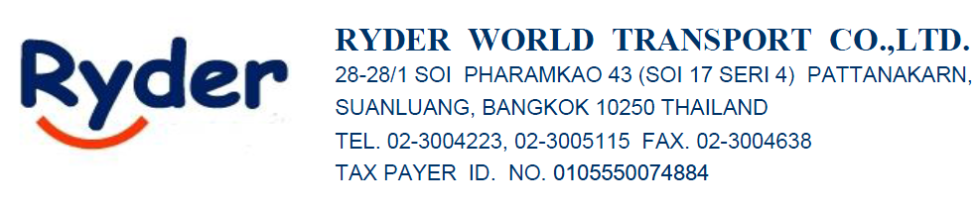
QUOTATION : RATE PORT SINGAPORE FCL(CIF) Validity date 31 Oct’23
DEAR : K. Noo

FCL FREIGHT RATE QUOTATION (EXPORT)
We are proudly present our air freight quotation for your kind consideration. Here below is the freight cost for your outbound delivery from Thailand to the destination ports of your requirement.

Port/Country | 20 | 40 | 40’HC | Frequency | Carrier | T/T
_{BKK-SINGAPORE} | _{$130} | _{$200} | _{$200} | _{WEEKLY} | _{Oceanblu} | _{3 DAY}
_{LCB-SINGAPORE} | _{$100} | _{$150} | _{$150} | _{WEEKLY} | _{Oceanblu} | _{3 DAY}
_{LKB-SINGAPORE} | _{$180} | _{$250} | _{$250} | _{WEEKLY} | _{Oceanblu} | _{3 DAY}

Local charges at Origins
-B/L FEE : THB 1,800/SET
-Surrender BL Fee : THB 1,800/SET
-THC : THB 2,800/20’ THB 4,300/40’
-B/L FEE : THB 300/SET

We hope that the above quotation could meet your kind requirement. For any further information, please contact us. Thanks in advance for your support.

Best Regards,
Sirisak Srisuwan (Sam)
Sales
Ryder World Transport Co., Ltd.
28-28/1 Soi Pharamkao 43 (Soi 17 Seri 4)
Pattanakarn, Suanluang, Bangkok 10250 THAILAND
Tel: (662)300 4223, (662)300 5115 (Ext. 215)
Mobile: (66)65-625-4945
Fax: (662)300 5092
Website: www.ryder.co.th

